Lab 10:
Create table sales and products using key constraints (primary and foreign key), insert suitable data and perform DML operation (select clause, where clause and aggregate functions).

SQL Queries:

- CREATE DATABASE lab10;
- USE lab10;
- CREATE TABLE products (
PID INT PRIMARY KEY,
PName VARCHAR(100) ,
Price DECIMAL(10, 2)
);

- CREATE TABLE Sales (
SID INT PRIMARY KEY,
PID INT,
Quantity INT,
SaleDate DATE,
FOREIGN KEY (PID) REFERENCES products(PID)
);

- INSERT INTO products (PID, PName, Price) VALUES
(1, 'Laptop', 120000),
(2, 'Smartphone', 8000.00),
(3, 'Tablet', 40000.00),
(4, 'Monitor', 25000),
(5, 'Keyboard', 500);

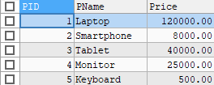

- INSERT INTO sales (SID, PID, Quantity, SaleDate) VALUES
(101, 1, 2, '2025-08-01'),
(102, 2, 3, '2025-08-02'),
(103, 1, 1, '2025-08-03'),
(104, 3, 4, '2025-08-03'),
(105, 5, 10, '2025-08-04'),
(106, 4, 1, '2025-08-05');
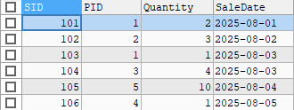

- To view sales with product details
SELECT
S.SID,
P.PName,
S.Quantity,
P.Price,
(S.Quantity * P.Price) AS TotalSaleAmount,
S.SaleDate
FROM sales S
JOIN products P ON S.PID = P.PID;

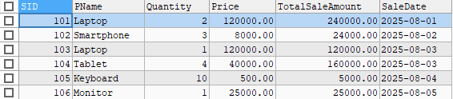

- To filter sales for a specific product using WHERE clause
SELECT
S.SID,
P.PName,
S.Quantity,
S.SaleDate
FROM Sales S
JOIN products P ON S.PID = P.PID
WHERE P.PName = 'Laptop';

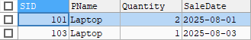

- To calculate total revenue and average quantity sold
SELECT
SUM(S.Quantity * P.Price) AS TotalRevenue
FROM sales S
JOIN products P ON S.PID = P.ID;


SELECT
AVG(Quantity) AS AvgQuantityPerSale
FROM Sales;


- To count total sales for each product
SELECT
P.PName,
COUNT(S.SaleID) AS TotalSales
FROM sales S
JOIN products P ON S.PID = P.PID
GROUP BY P.PName;
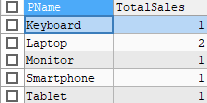

Lab 9:
Create table student with suitable attributes and insert 10-15 records and perform the matching operation using LIKE keywords and use all given char functions (substring, concat, length, upper, lower, trim, ltrim, rtrim, char, ascii).
SQL Queries:
- CREATE DATABASE lab9;
- USE lab9;
- CREATE TABLE student(
eid INT(3),
ename VARCHAR(20),
eaddress VARCHAR(20),
ephone NUMERIC(10),
eage INT(3)
);
- INSERT INTO student VALUES
(1, ' Anshu Hada ', ' Dhobidhara-30 ', 9812345601, 22),
(2, ' Barsha Pandey ', ' Dillibazar-5 ', 9812345602, 25),
(3, ' Gaurav Thapa ', ' Baneshwor-2', 9812345603, 30),
(4, ' Manila Aryal', 'Kalanki-1 ', 9812345604, 28),
(5, 'Kamana Shrestha ', ' Putalisadak-4 ', 9812345605, 22),
(6, ' Shrisha Tuladhar ', ' Kirtipur-6 ', 9812345606, 24),
(7, ' Krisma Maharjan', 'Gausala-7 ', 9812345607, 31),
(8, ' Sudip Khadka ', ' Maitidevi-2', 9812345609, 29),
(9, 'Ayush Tuladhar ', 'Balkot-3 ', 9812345609, 26),
(10, ' Sangam Adhikari ', ' Sankhamul-9 ', 9812345610, 23),
(11, ' Abhilekh Sudebi', ' Gongabu-4 ', 9812345611, 32),
(12, 'Hrikesh Aran ', ' Balaju-10 ', 9812345612, 30),
(13, ' Upendra Panta ', ' Samakhushi-5', 9812345613, 33),
(14, ' Anush Shrestha', 'New Baneshwor-8 ', 9812345614, 28),
(15, ' Ashlesha Shrestha ', ' Jorpati-3 ', 9812345615, 27);

- SELECT *FROM student WHERE ename LIKE '%a%';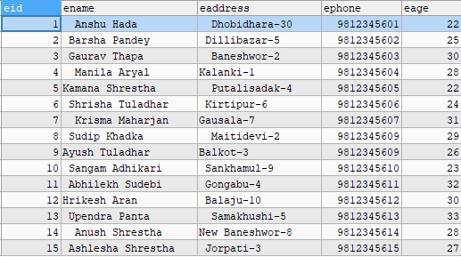

- SELECT *FROM student WHERE eaddress LIKE '%Balaju%';

- SELECT *FROM student WHERE ephone LIKE '%15';

- SELECT eid, SUBSTRING(ename,1,5) AS Name5 FROM student WHERE eid<5;
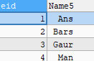
- SELECT CONCAT(eid, ' ', ename) AS primarykey FROM student;
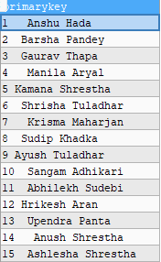

- SELECT eaddress, LENGTH(eaddress) AS Addresslength FROM student;
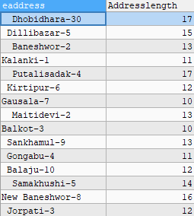

- SELECT ename, UPPER(ename) AS UpperName, LOWER(ename) AS LowerName FROM student;
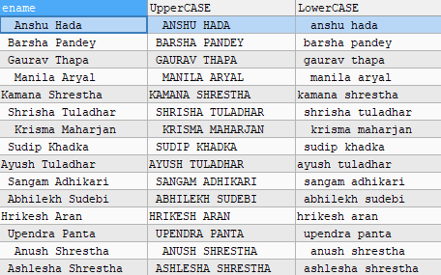

- SELECT
TRIM(ename) AS TrimmedName,
LTRIM(eaddress) AS LeftTrimmed,
RTRIM(ename) AS RightTrimmed
FROM student;
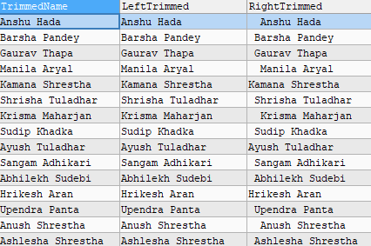
- SELECT
ename,
ASCII(SUBSTRING(LTRIM(ename), 1, 1)) AS firstcharASCII
FROM student;
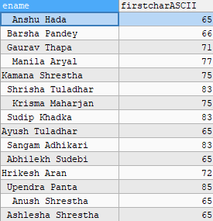
- SELECT
ename,
eage,
CHAR(ASCII(SUBSTRING(CAST(eage AS CHAR), 1, 1))) AS FirstChar
FROM student;
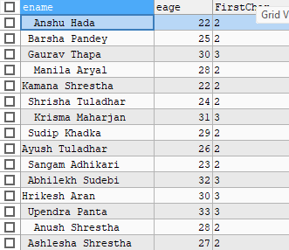

Lab 11:
- Write sql code to create alias name of existing attributes.
- Create table teacher with suitable fields
- Insert seven records.
- Give increment of 30% salary of computer department.
- Give increment of 50% of salary who works more than 10 years.
- Find the highest paying and lowest paying teacher from math department
SQL Queries:
- CREATE databas0e lab11;
- USE lab11;
- CREATE TABLE teacher (
teacher_id INT PRIMARY KEY,
teacher_name VARCHAR(100),
department VARCHAR(50),
salary DECIMAL(10, 2),
years_of_experience INT
);
- INSERT INTO teacher (teacher_id, teacher_name, department, salary, years_of_experience) VALUES
(1, 'Alice Smith', 'Math', 50000, 12),
(2, 'Bob Johnson', 'Computer', 60000, 9),
(3, 'Carol Lee', 'Math', 55000, 7),
(4, 'David Kim', 'Computer', 62000, 11),
(5, 'Eva Brown', 'Physics', 52000, 15),
(6, 'Frank White', 'Computer', 58000, 4),
(7, 'Grace Green', 'Math', 49000, 10);
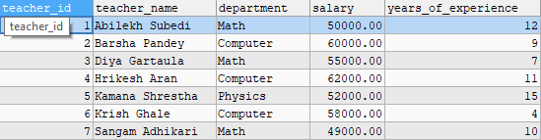

- To give increment of 30% of salary of computer department.
UPDATE teacher
SET salary = salary * 1.30
WHERE department = 'Computer';
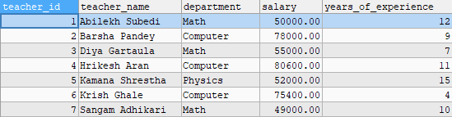

- To give increment of 50% of salary who works more than 10 years.
UPDATE teacher
SET salary = salary * 1.50
WHERE years_of_experience > 10;
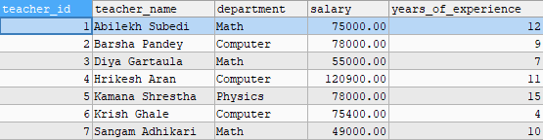

- To find the highest paying and lowest paying teacher from math department
SELECT *
FROM teacher
WHERE department = 'Math'
AND salary = (SELECT MAX(salary) FROM teacher WHERE department = 'Math');

SELECT *
FROM teacher
WHERE department = 'Math'
AND salary = (SELECT MIN(salary) FROM teacher WHERE department = 'Math');

- To create alias name of existing attributes.
SELECT
teacher_id AS ID,
teacher_name AS NAME,
department AS Dept,
salary AS Salary,
years_of_experience AS Experience
FROM teacher;
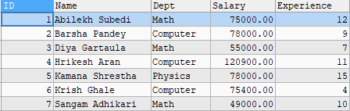

LAB 8: Write SQL code to display records using cross, equi and self join.
SQL Queries:

- CREATE DATABASE lab8;
- USE lab8;
- CREATE TABLE department (
department_id INT PRIMARY KEY,
department_name VARCHAR(50)
);
- CREATE TABLE employee (
emp_id INT PRIMARY KEY,
NAME VARCHAR(50),
department_id INT,
manager_id INT
);
- INSERT INTO department (department_id, department_name) VALUES
(10, 'HR'),
(20, 'IT'),
(30, 'Sales');
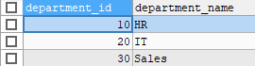

- INSERT INTO employee (emp_id, NAME, department_id, manager_id) VALUES
(1, 'Abilekh', 10, NULL),
(2, 'Alisha', 20, 1),
(3, 'Anshu', 10, 1),
(4, 'Anush', 30, 2);
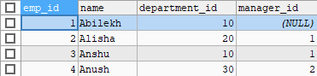

- Displaying data using Cross join.
SELECT e.name AS employee_name, d.department_name
FROM employee e
CROSS JOIN department d;

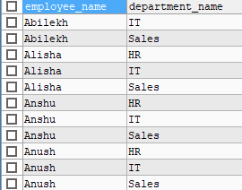

- Displaying data using Equi join.
SELECT e.name AS employee_name, d.department_name
FROM employee e
JOIN department d ON e.department_id = d.department_id;
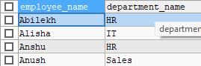

- Displaying data using Self join.
SELECT e.name AS employee_name, m.name AS manager_name
FROM employee e
JOIN employee m ON e.manager_id = m.emp_id;

